What is CIS Benchmark:

A CIS benchmark contains guidance from the Center for Internet Security (CIS) on best practices for configuring IT systems, networks, and software. The CIS has released over 140 benchmarks with the support of cybersecurity professionals and subject matter experts in communities worldwide.

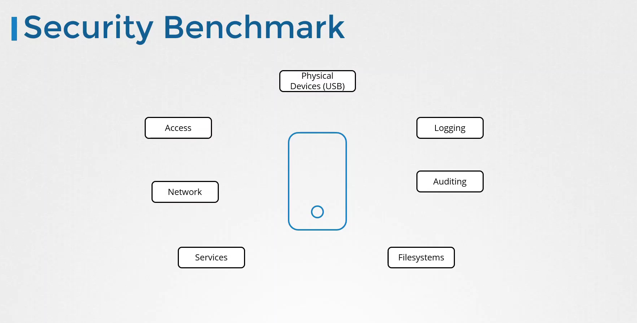

CSI BenchMark:

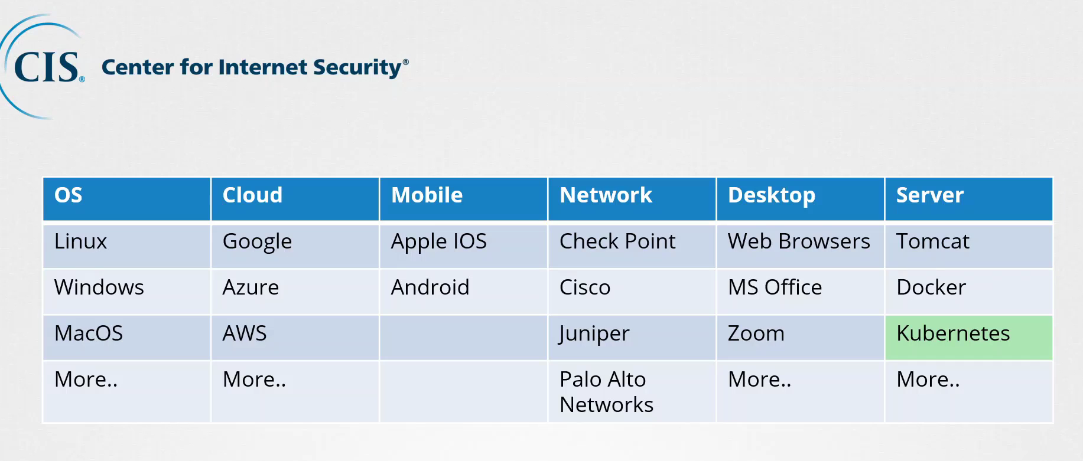

Download the Benchmarks :

<https://www.cisecurity.org/cis-benchmarks>

**Download the CIS benchmark PDF’s from the below link:**

[**https://www.cisecurity.org/cis-benchmarks/#kubernetes**](https://www.cisecurity.org/cis-benchmarks/#kubernetes)

**Go to the `Server Software` section and click on the `Virtualization`.**

**There you will see multiple items that fall into the virtualization category such as VMware, docker and kubernetes. Now, move on to the Kubernetes and expand it to see more options then download CIS Kubernetes Benchmark version 1.6.0.**

**Download the CIS CAT tool’ from the below link:**

[**https://www.cisecurity.org/cybersecurity-tools/cis-cat-pro/cis-benchmarks-supported-by-cis-cat-pro/**](https://www.cisecurity.org/cybersecurity-tools/cis-cat-pro/cis-benchmarks-supported-by-cis-cat-pro/)

**Download the CIS CAT Lite tool from the below link:**

[**https://learn.cisecurity.org/cis-cat-lite**](https://learn.cisecurity.org/cis-cat-lite)

**Install Kube-Bench To Perform Security Check :**

[**https://github.com/aquasecurity/kube-bench/blob/main/docs/installation.md**](https://github.com/aquasecurity/kube-bench/blob/main/docs/installation.md)

**Create a Kubernetes service Accounts :**

**Kubectl create serviceaccount sa1**

**Kubectl get serviceaccount**

**To Create a Service Account Dashboards :**

**kubectl create serviceaccount dashboard-sa**

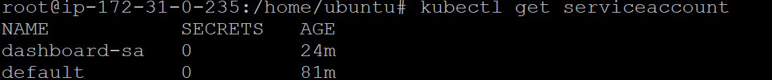

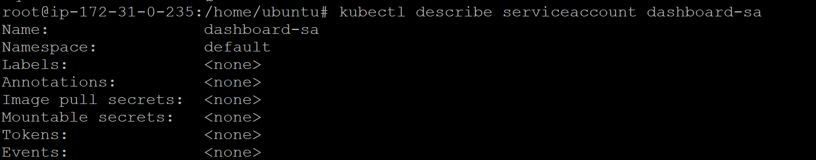

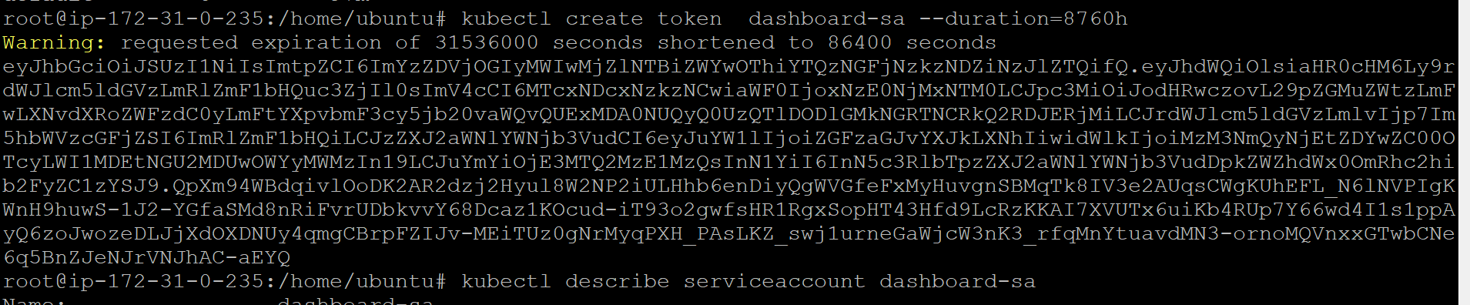

**To Check the Token :**

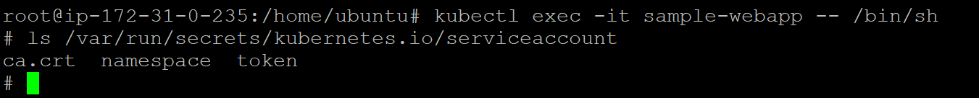

**To View the token :**

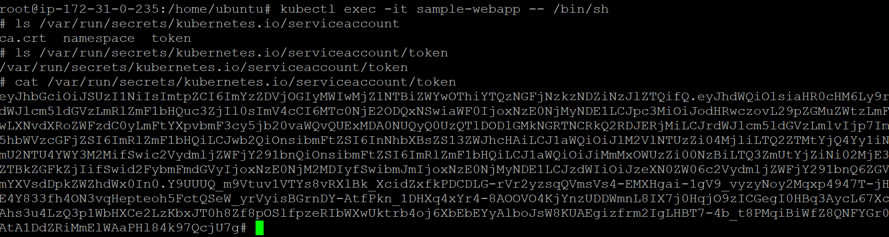

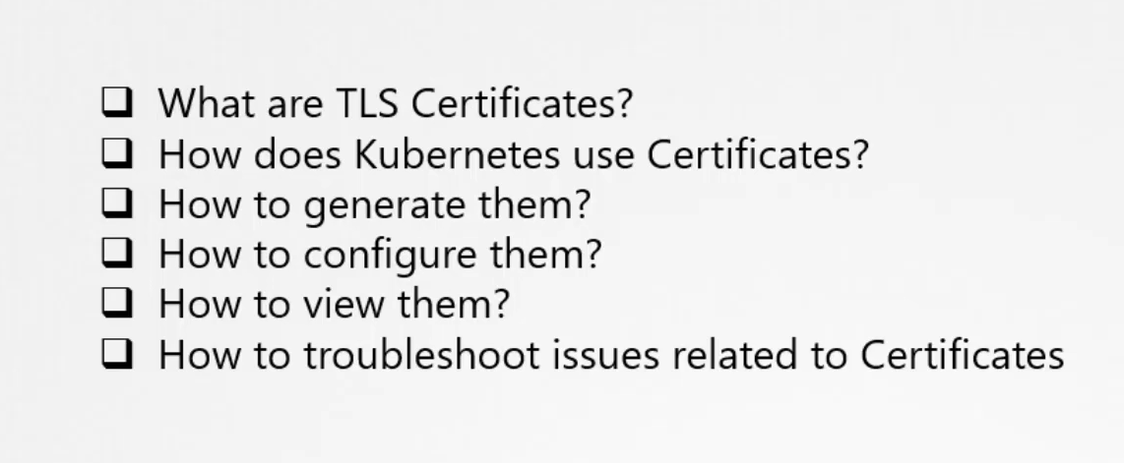

**Symmetric Encryption:**

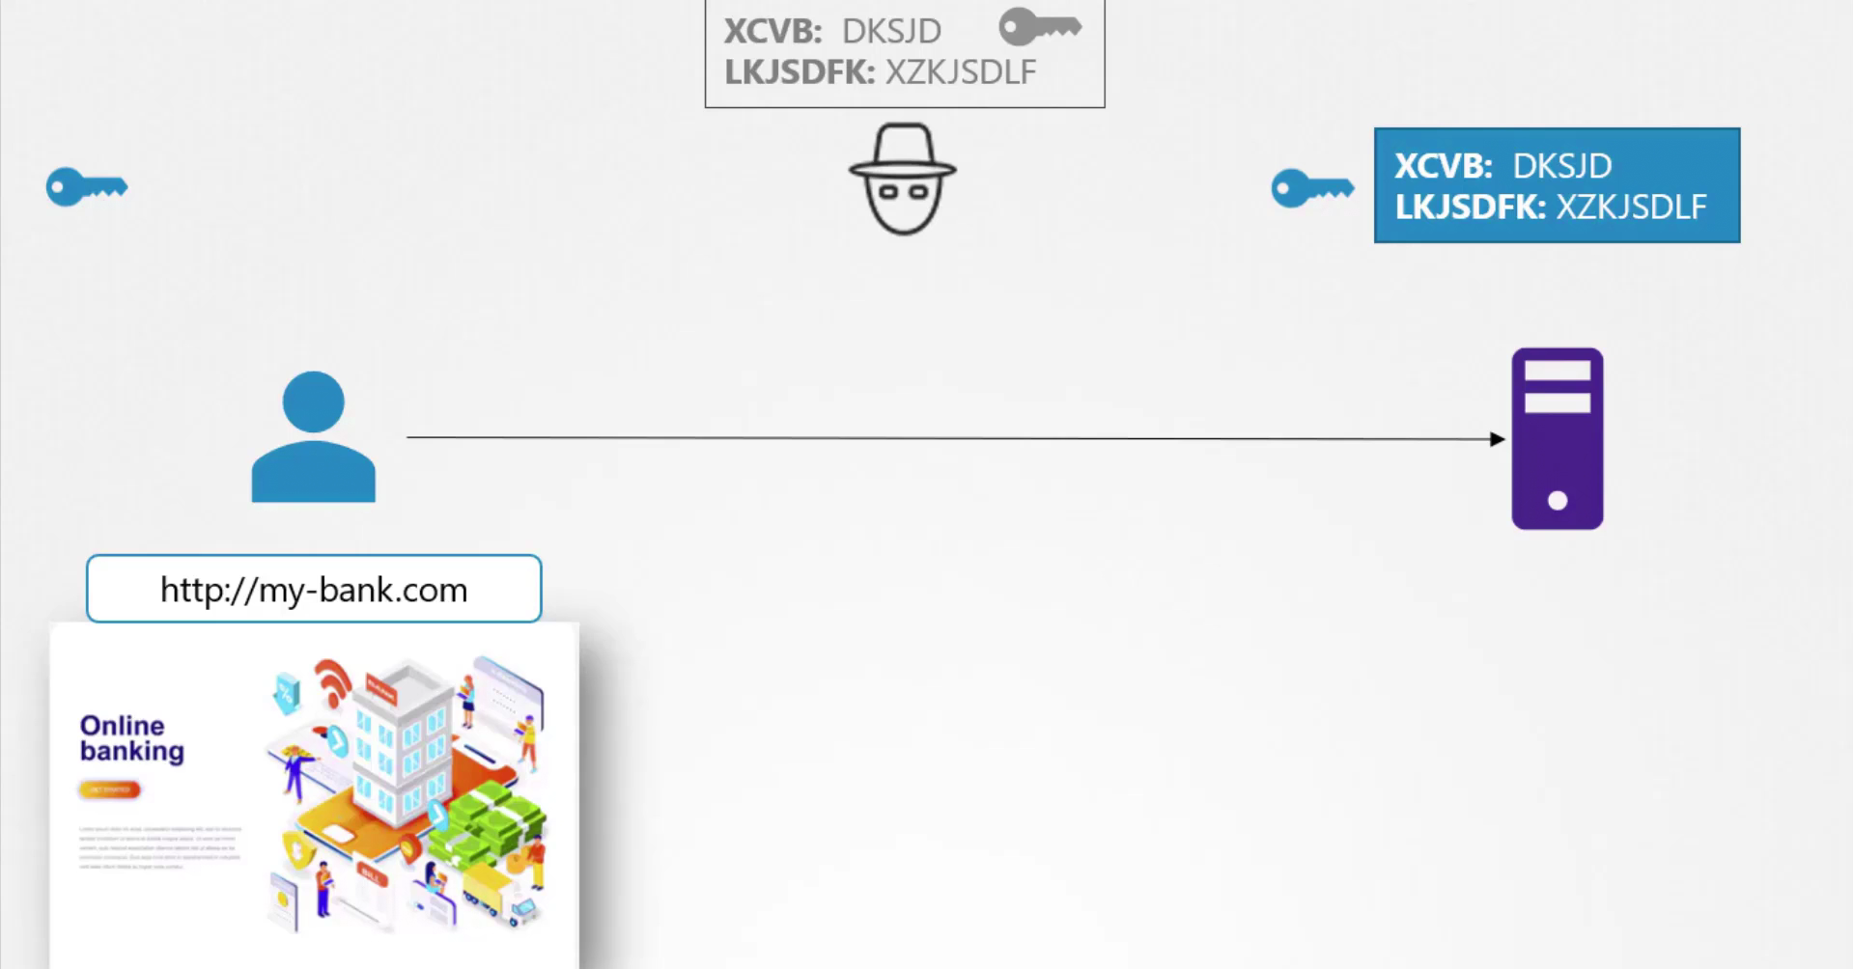

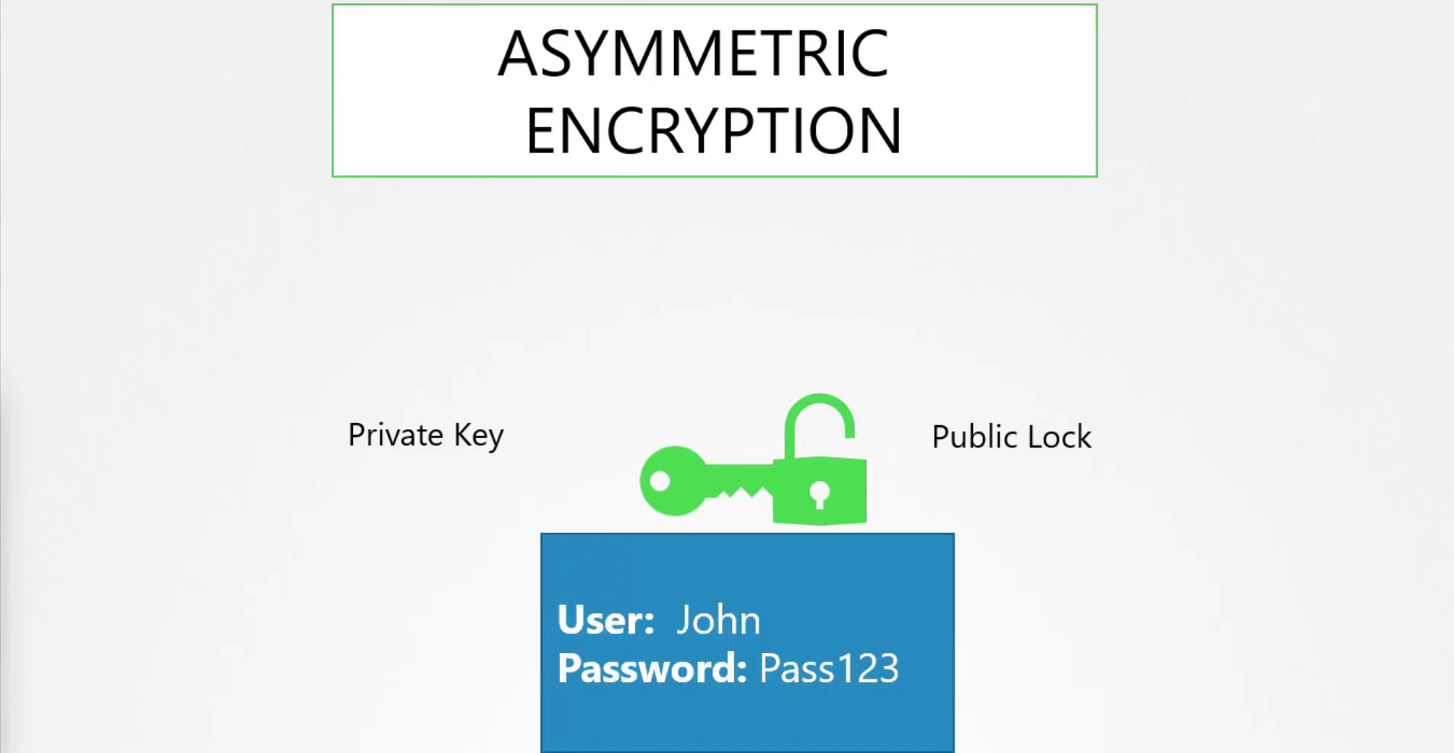

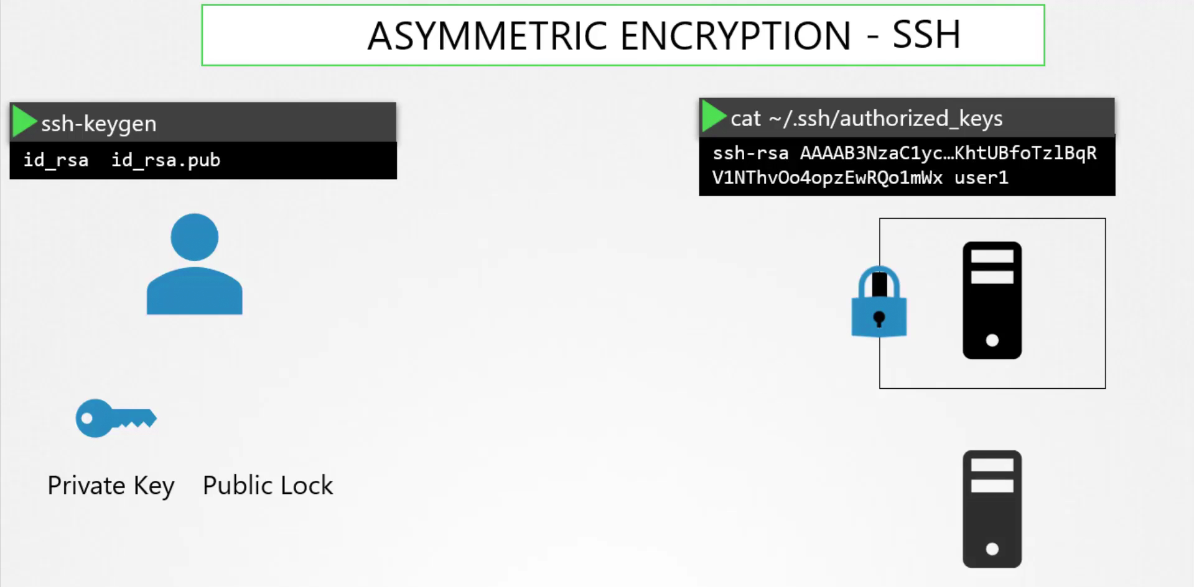



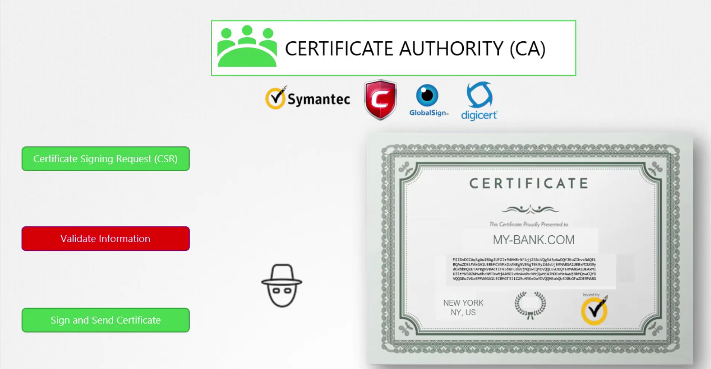

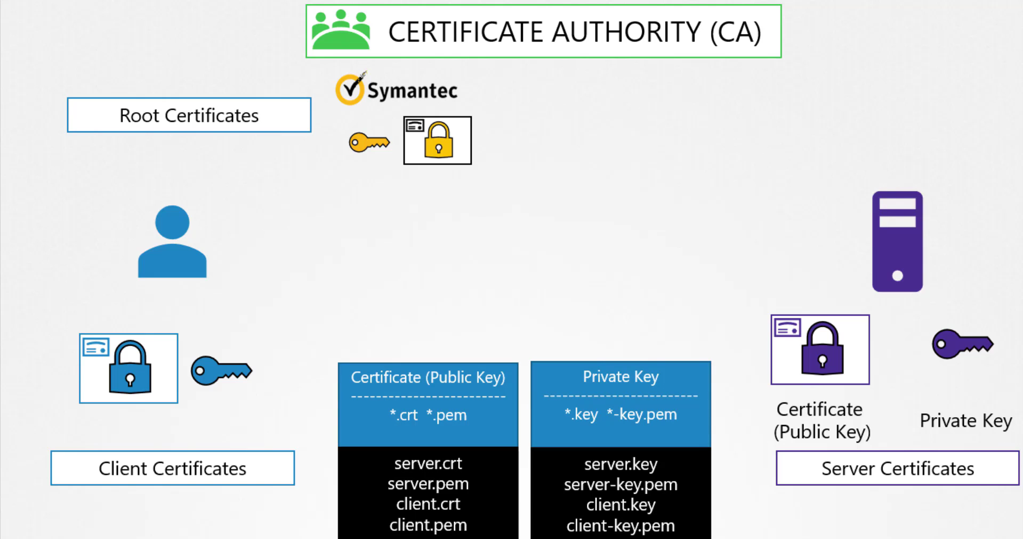

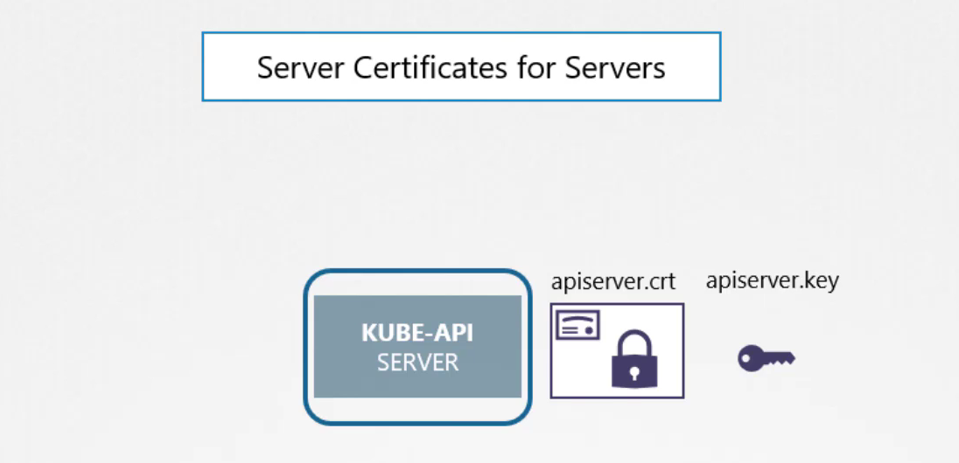

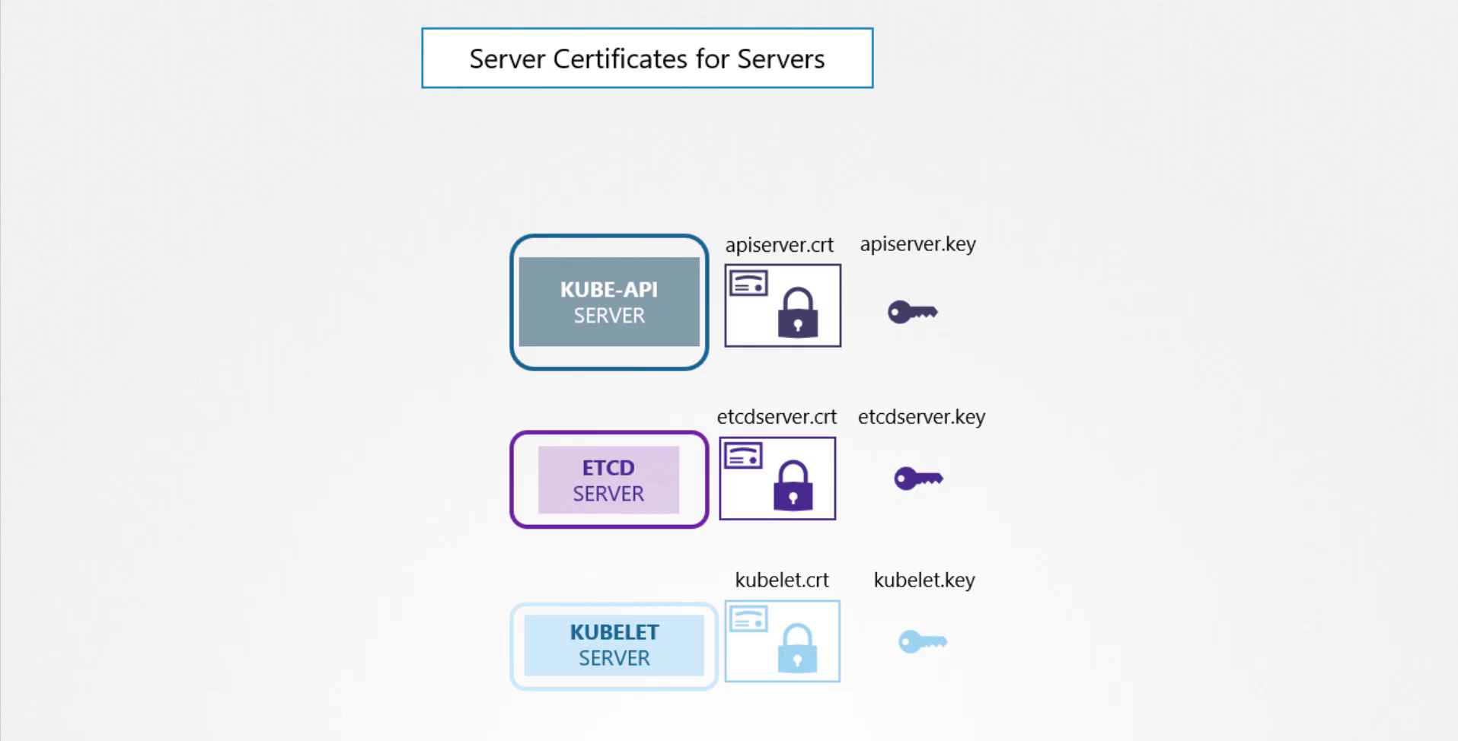

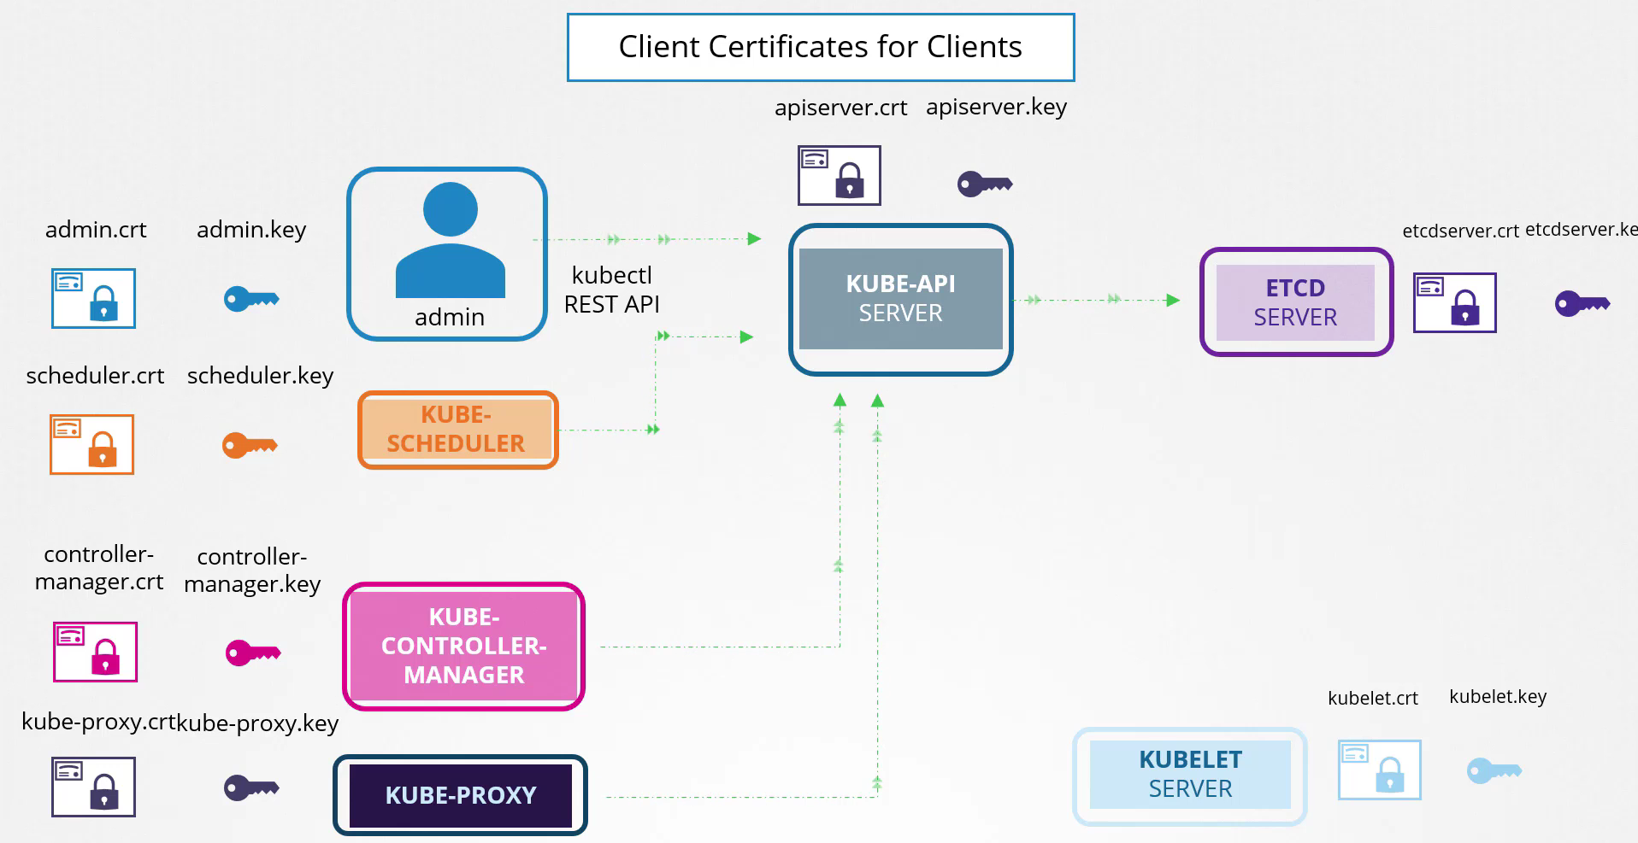

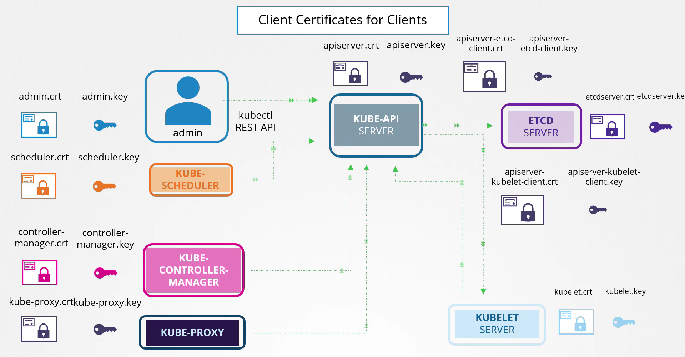

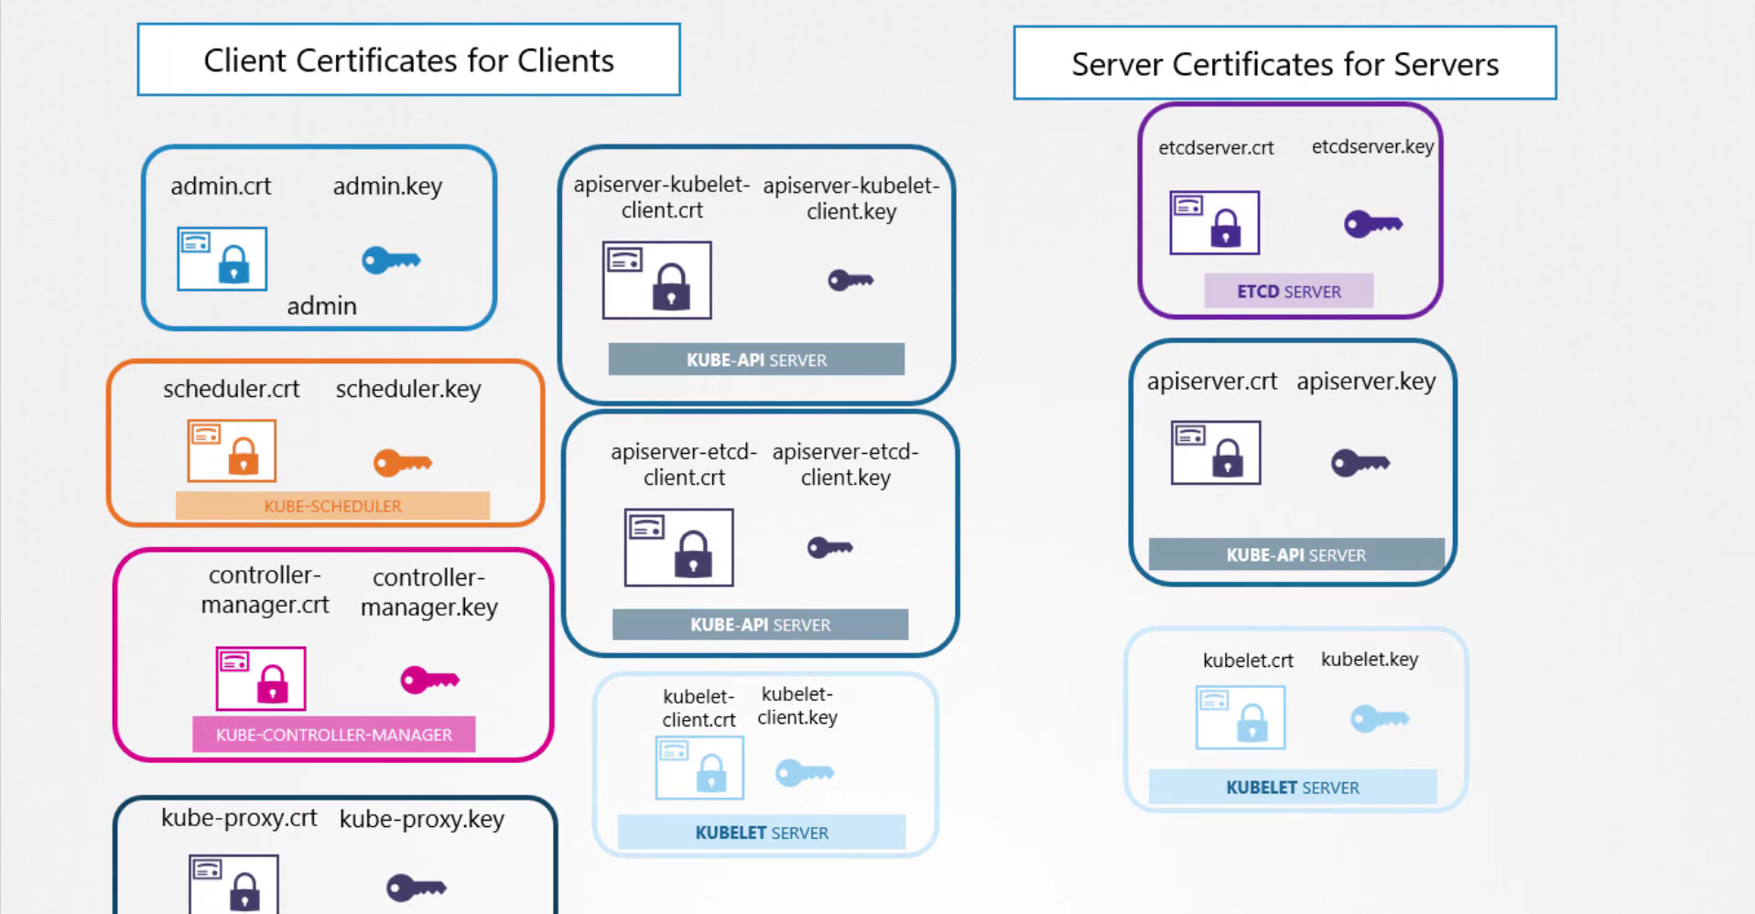

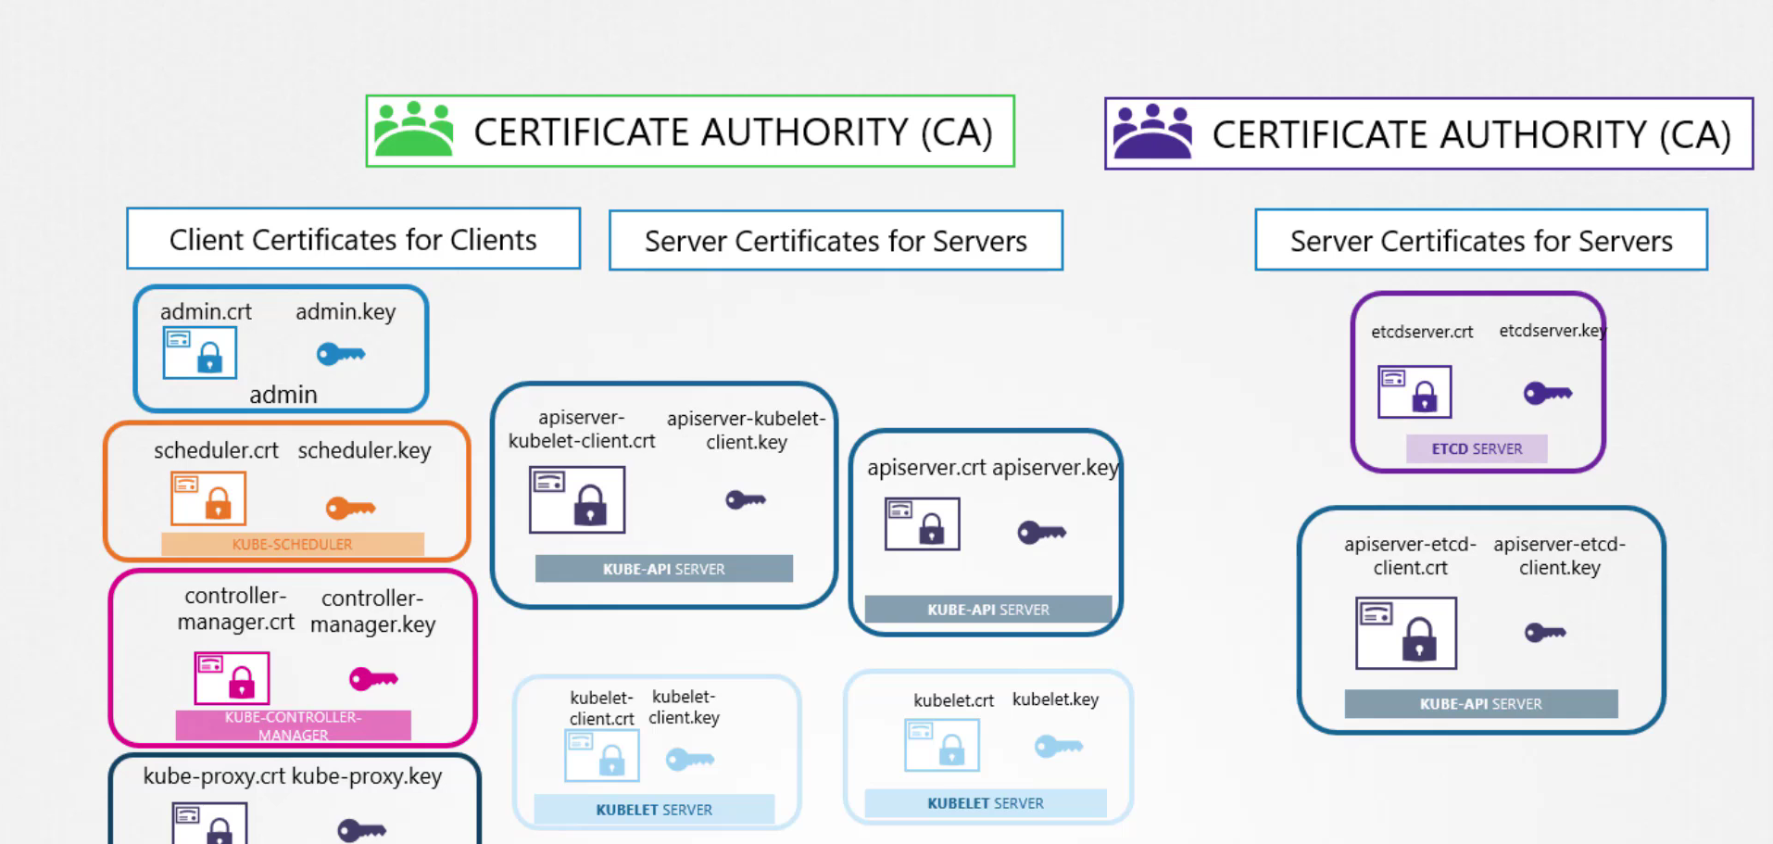

**How to generate certificates for the cluster:**

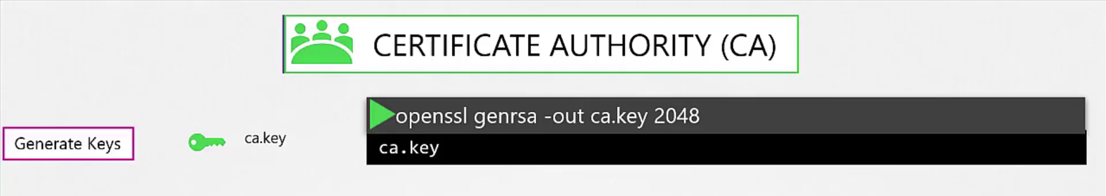



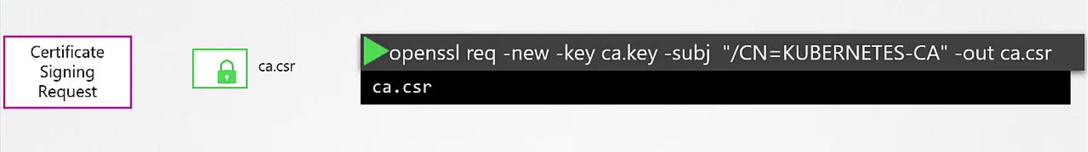



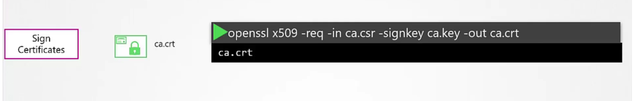



**Generate a sign key and Crt for the Kubernetes Admin User :**

**Generate a Key : openssl genrsa –out admin.key 2048**



**Certificate Signing Request : openssl req –new –key admin.key –subj “/CN=kube-admin” –out admin.csr**



**Sign Certificate :**

**openssl x509 -req -in admin.csr -CA ca.crt -CAkey ca.key -out admin.crt**



**Generate the Client Certificates as well :**

**System-schedular.key , System-schedular.csr , system-schedular.crt**

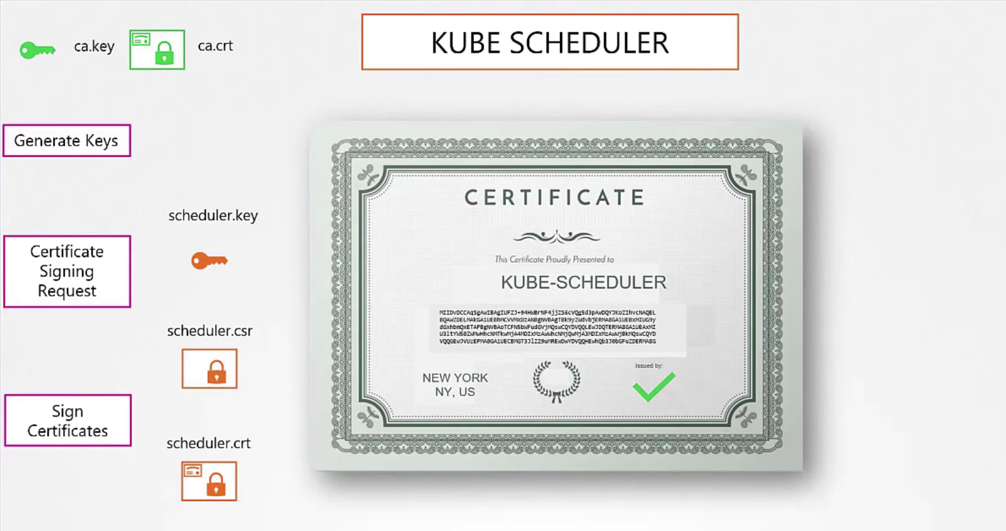

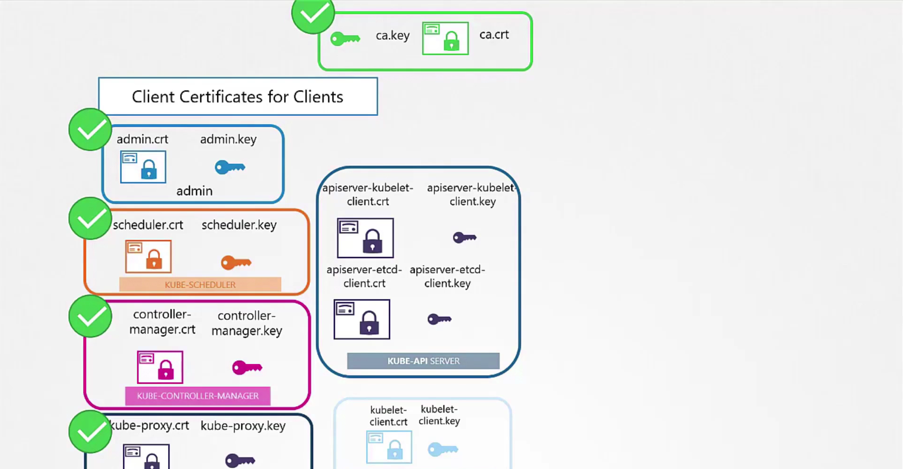

**curl https://kube-apiserver:6443/api/v1/pod --key admin.key --cert admin.crt --cacert ca.crt**

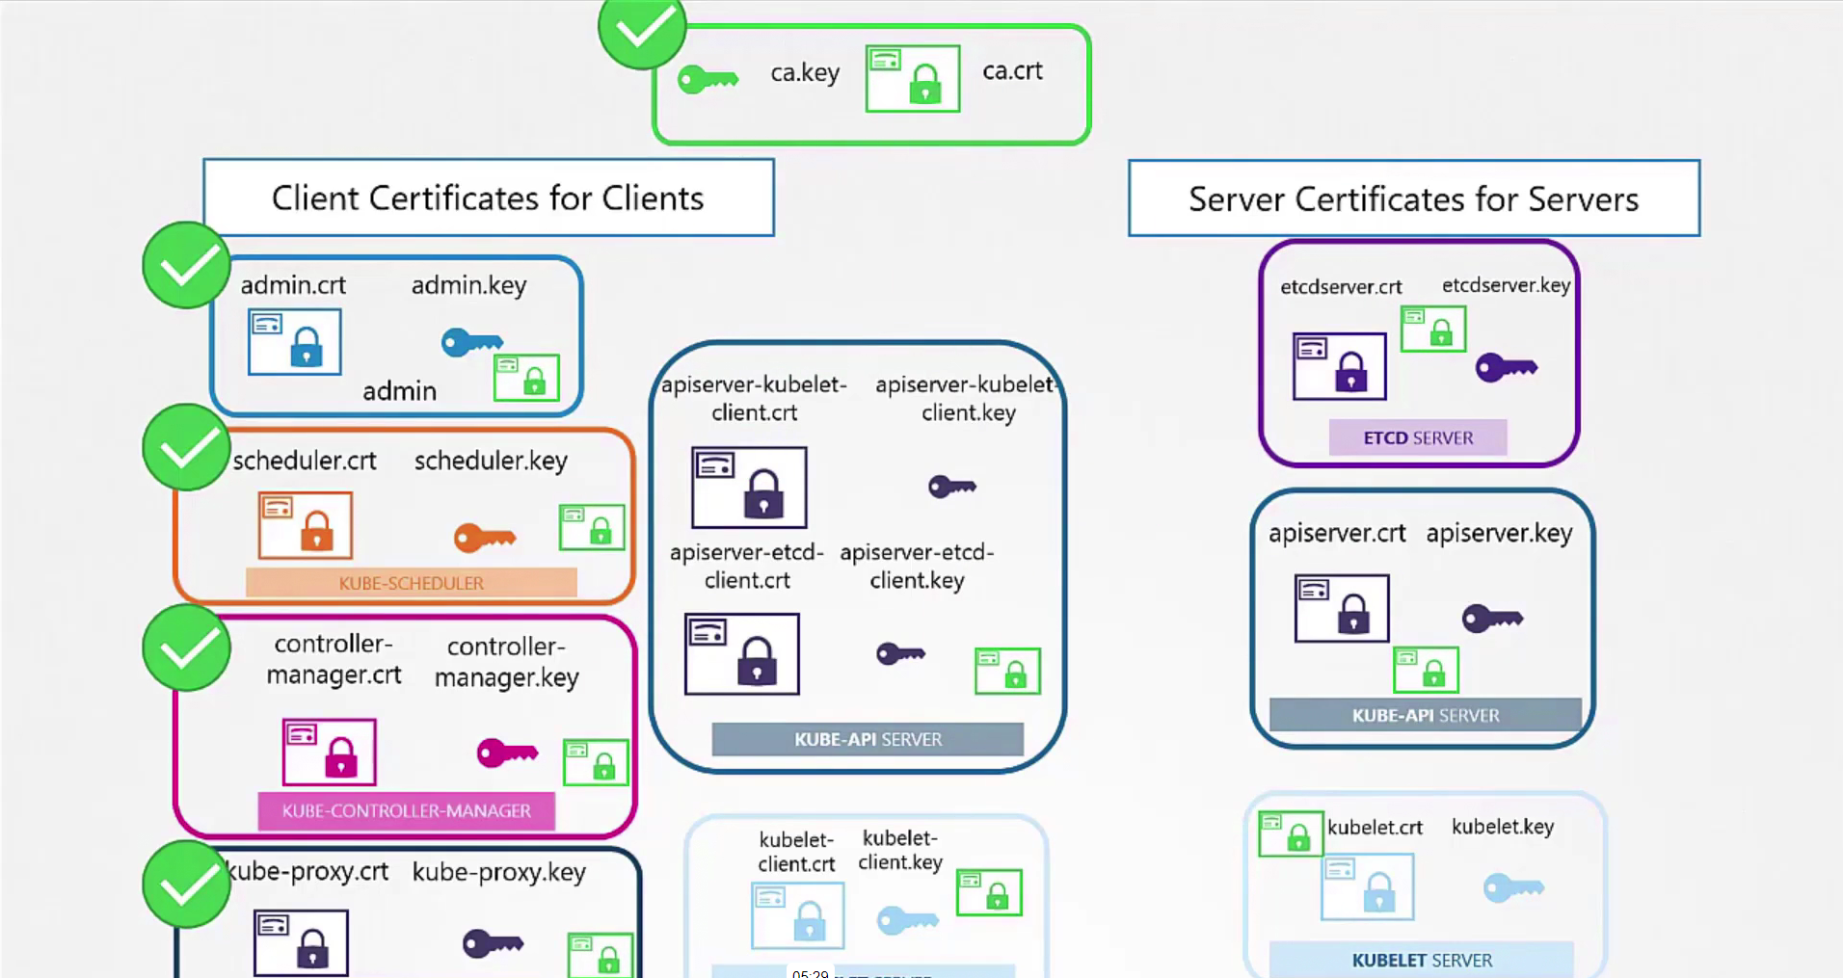

ETCD BACKUP :

Restore a snapshot from a particular backup :

Kubectl create deploy nginx –image nginx

Install ETCD :

<https://github.com/etcd-io/etcd/releases/download/v3.5.13/etcd-v3.5.13-linux-amd64.tar.gz>

tar –xvzf etcd-v3.5.13-linux-amd64.tar.gz

ls –la

cd etcd-v3.5.13-linux-amd64

$echo PATH

Cp etcd* /usr/bin/

Exectute the Command:

Etcdctl

Ls –la /usr/bin : Endpoint , CA, Client Cert , Client Key

Steps we have to follow :

1. Create a snapshot on a particular location
2. Restore a snapshot on a particular location

Step1 : We need ca cert certification location :

Ls /etc/kubernetes/pki/ca.crt

If we need to see all the certifications :

cat /etc/kubernetes/manifests/etcd.yaml | grep -i files*

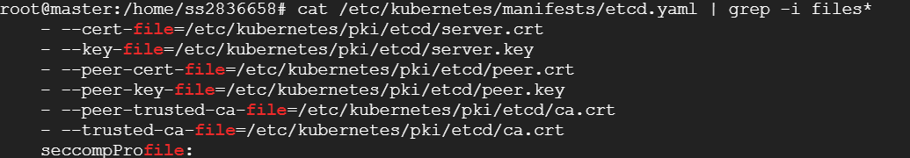

Create a Snapshot File :

ETCDCTL_API=3 etcdctl --endpoints=https://127.0.0.1:2379 --cacert=/etc/kubernetes/pki/etcd/ca.crt --cert=/etc/kubernetes/pki/etcd/server.crt --key=/etc/kubernetes/pki/etcd/server.key snapshot save newbackup.db

ls var/lib

Restore a Key :

ETCDCTL_API=3 etcdctl --endpoints=https://127.0.0.1:2379 --cacert=/etc/kubernetes/pki/etcd/ca.crt --cert=/etc/kubernetes/pki/etcd/server.crt --key=/etc/kubernetes/pki/etcd/server.key --data-dir=/var/lib/etcd-backup snapshot restore newbackup.db

Helm Charts :

Helm create first-chart – It will create one folder that is called first-chart

Create Chart.yaml File

Create Templates Folder – Inside defile your yaml files

Helm list

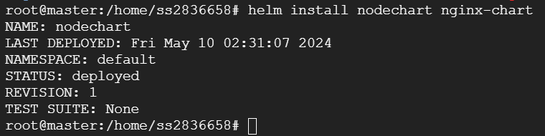

Helm upgrade nodechart nginx-chart

Helm uninstall nodechart

Helm upgrade nodechart –values vauesfilename location of the folder

Dynamic Values : --set

<https://kubernetes.io/docs/tasks/tools/>

https://github.com/kubernetes/kubernetes/releases